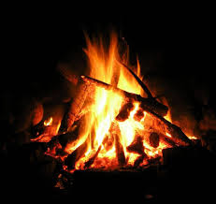
Bon-fire:
Just the heat and light you need when dusk passes by for the liveliest feel in Nilgiris, Ooty.

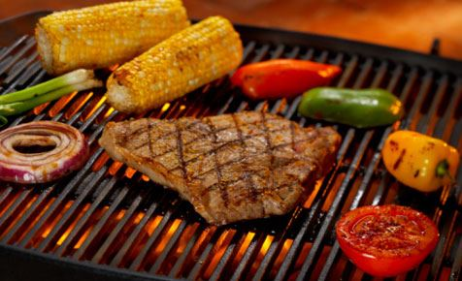

Open Fire Stove & Barbeque:
Sizzling & finger licking cuisine of your choice in the hot and grilled open fire stove.

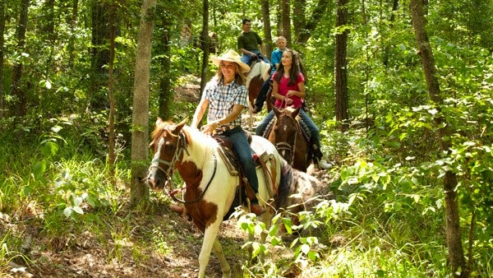
Horseback Riding:
Riders can experience being on horseback in a relaxed, safe environment on well trained horses and ponies.
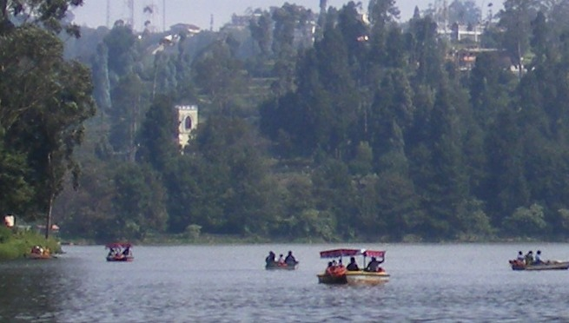
Boating:
Float your way to leisure in the lakes of Coonoor and Ooty for you will be mesmerized in the feel of the mountain lakes.

Golf Course:
Live it in the 18-hole golf course at one of the finest natural golf courses in the world at 6000 and 7000 ft above MSL in the avalanche range surrounded by the heavily wooded trees of Coonoor and Ooty.
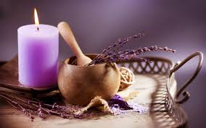
Aromatherapy & Herbal Spa:
Indulge yourself in the Aroma of scents and soothe your mind and body to our herbal oils with our expert therapists to chant you into your dream world.

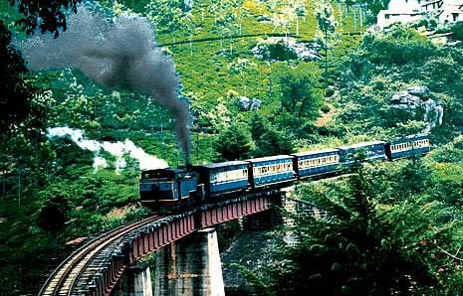

Steam Nilgiri Mountain Train:
Take a ride on one of a kind, Heritage Steam Engine through the Blue mountains of Nilgiris from Coonoor and Ooty.
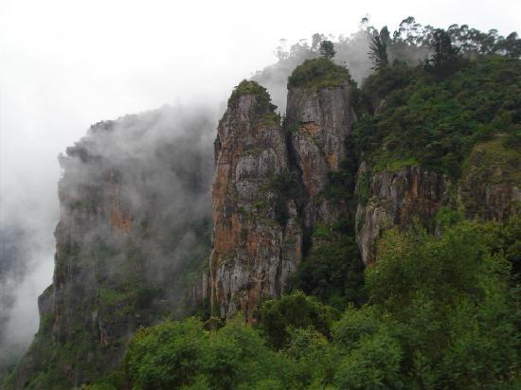
Mountaineering:
Trek into the blue hills safely with our trained veterans of the Nilgiris. Make it an adventure with the Nilgiri wildlife and natural springs that keep you going

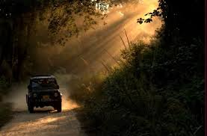
Forest Safari Services:
Treat your nerves, before dawn, with family and friends into the mudumalai forest and the nearby for an expedition into the wild and safe encounters.
Cabs & Valets:
We take pleasure in riding you to our lavish services and memorable stay and also wave you off with a smile in our comfortable cab services just for you.
Open Lawn Dining:
Dine in the open with your family in the cool breeze of the Nilgiris.
Restaurant & Buffet setup:
Gaze at the meadows of the Nilgiris and dine with family and friends to a treat of your favorite dishes.

